*Press Release*

**GMA Pinoy TV Calls on Consul General Austria**

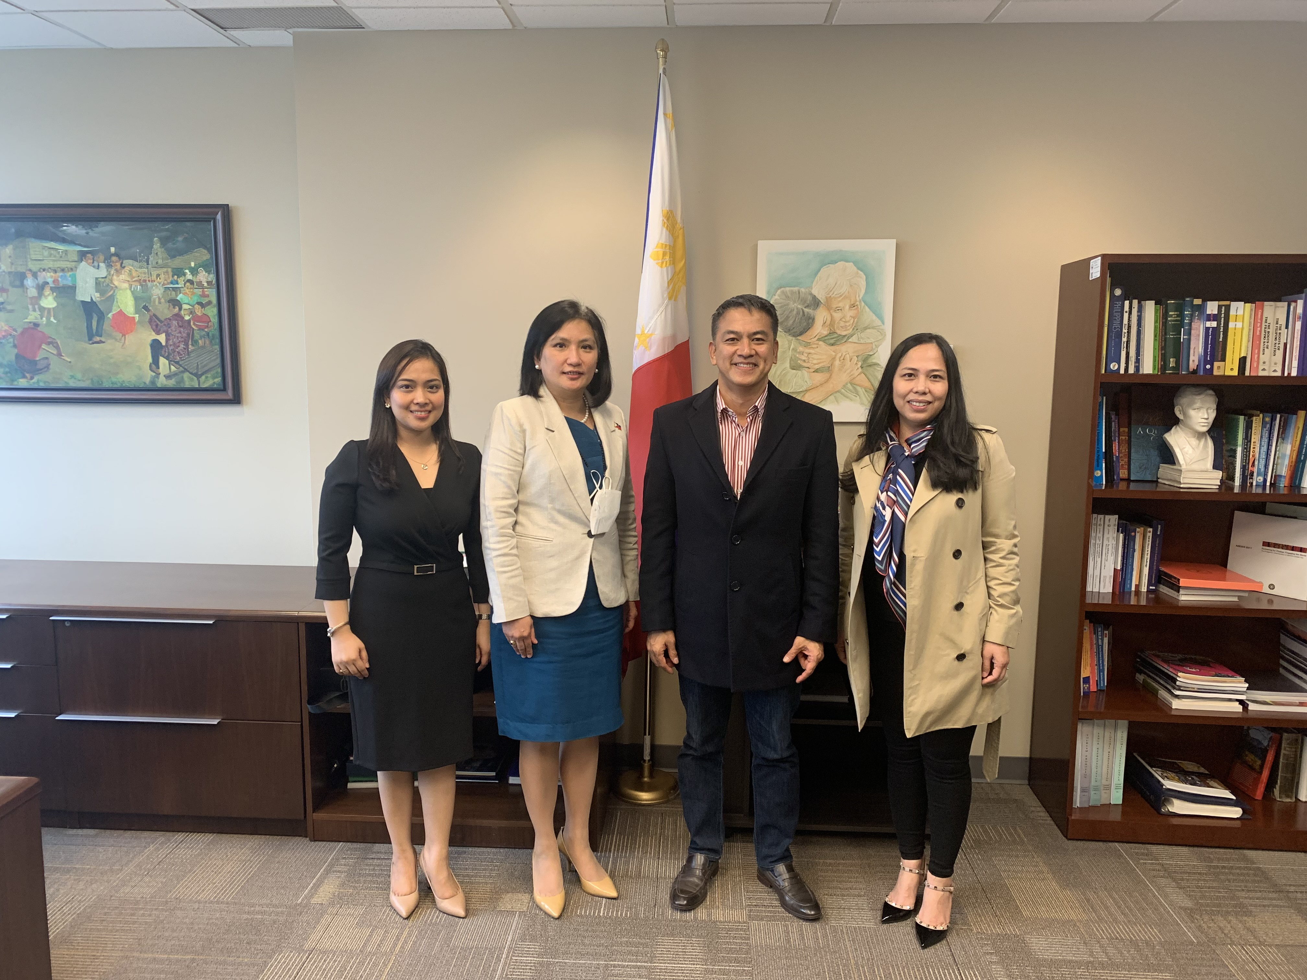

*Consul General Maria Andrelita Austria (2L) receives GMA International’s First Vice President and Head of Operations Joseph T. Francia (2R) at the Consulate on 30 May 2022. Also in the photo are Consul Analyn Ratonel and Ms. Faye Nalicat. (Photo from Vancouver PCG)*

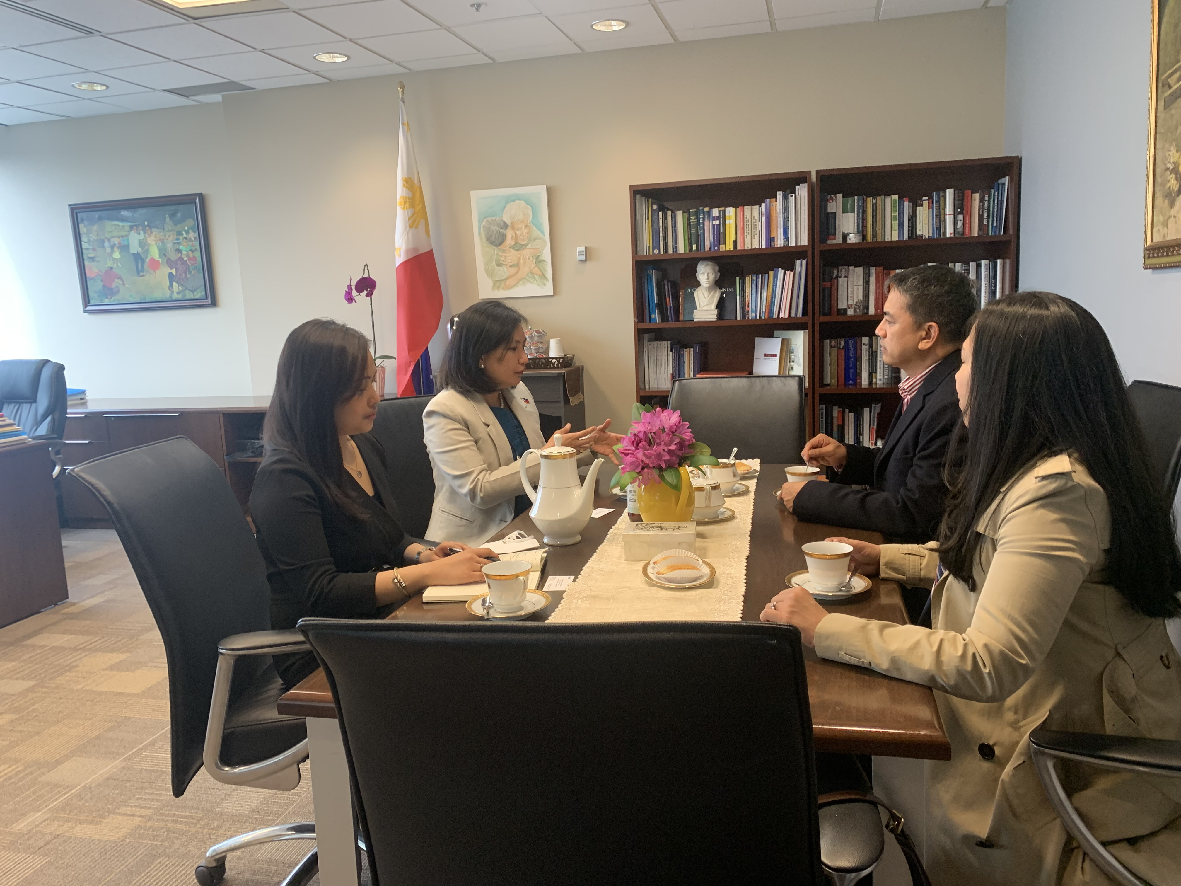

07 June 2022 – Consul General Maria Andrelita Austria received GMA International’s First Vice President and Head of Operations Joseph T. Francia at the Consulate on 30 May 2022. He was accompanied by Ms. Faye Nalicat, a marketing specialist based in Vancouver.

Consul General Austria briefed them on the Consulate’s forthcoming economic and cultural diplomacy projects.

Mr. Francia conveyed GMA Pinoy TV’s interest in collaborating with the Consulate on activities highlighting the best of the Philippines. *END*